- List 3 repetitive actions you perform while using any app like Instagram, Zomato, or Flipkart that could be automated with a script or tool. For each, briefly explain why automation would help.
Ans:
- Checking Instagram notifications – A script can automatically check and organize notifications at regular intervals. This saves time and avoids repeatedly opening the app.
- Tracking Zomato order status – Automation can regularly check the order status and notify the user when the order is confirmed, prepared, or out for delivery. This reduces manual checking.
- Searching for products on Flipkart – A script can automatically search for a specific product and compare prices or availability. This saves time and helps find the best deal quickly.
- Open Selenium IDE (install if needed), record a test that automates logging in to any demo website (e.g., https://opensource-demo.orangehrmlive.com/), and play it back to verify the steps are automated. Use the 'Record' button, perform login steps, then 'Stop Recording' and use 'Play current test case'.
Ans:
Selenium IDE Login Automation
Demo Website: OrangeHRM Demo
- Install Selenium IDE
  - Open Chrome/Firefox.
  - Go to the browser extension store.
  - Search for Selenium IDE and install it.
  - Open Selenium IDE after installation.
- Create a New Project
  - Click Create a new project.
  - Project name: OrangeHRM Login Test
  - Enter the website URL:
https://opensource-demo.orangehrmlive.com/
- Start Recording
  - Click Record.
  - Enter the website URL and open it.
  - Perform the login:
    - Username: Admin
    - Password: admin123
    - Click Login.
- Stop Recording
  - After successful login, return to Selenium IDE.
  - Click Stop Recording.
  - Selenium IDE should now show the recorded commands, such as:
    - open
    - type
    - click
- Play the Test
  - Select the recorded test case.
  - Click Play current test case.
  - Selenium IDE will automatically execute the recorded steps.
- Verify Result
  - If the login is successful and the dashboard appears, the test has passed.
  - Check that Selenium IDE shows successful execution without errors.
3. Download and launch Katalon Studio, then explore its UI to find where you can create a new test case, add test steps, and run tests. Take screenshots of these three areas and submit them.
Ans:
Katalon Studio – UI Exploration
- Create a New Test Case
  - Launch Katalon Studio.
  - In the Test Explorer panel, locate Test Cases.
  - Right-click Test Cases → New → Test Case.
  - Enter a name such as Login Test.
  - Screenshot 1: Capture the area showing Test Cases → New Test Case.
- Add Test Steps
  - Open the newly created test case.
  - Use the Manual view to add test steps.
  - Click Add and select the required keyword/action, such as Open Browser, Navigate to URL, Click, or Set Text.
  - Screenshot 2: Capture the Manual view/Test Steps area.
- Run the Test
  - Open the test case.
  - Click the Run button in the toolbar.
  - Select the desired browser, such as Chrome.
  - Katalon will execute the test steps and display the execution result.
  - Screenshot 3: Capture the Run button/browser selection or execution result area.

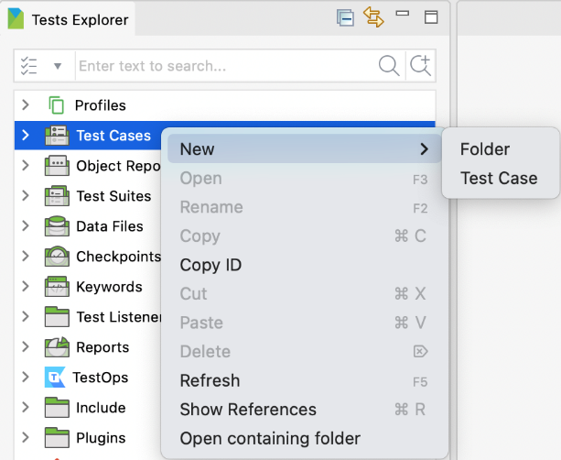
1. Create New Test Case

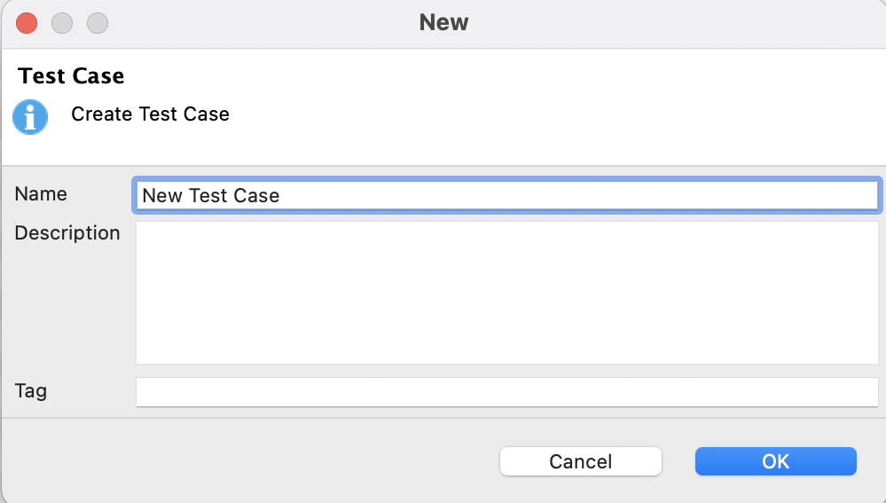

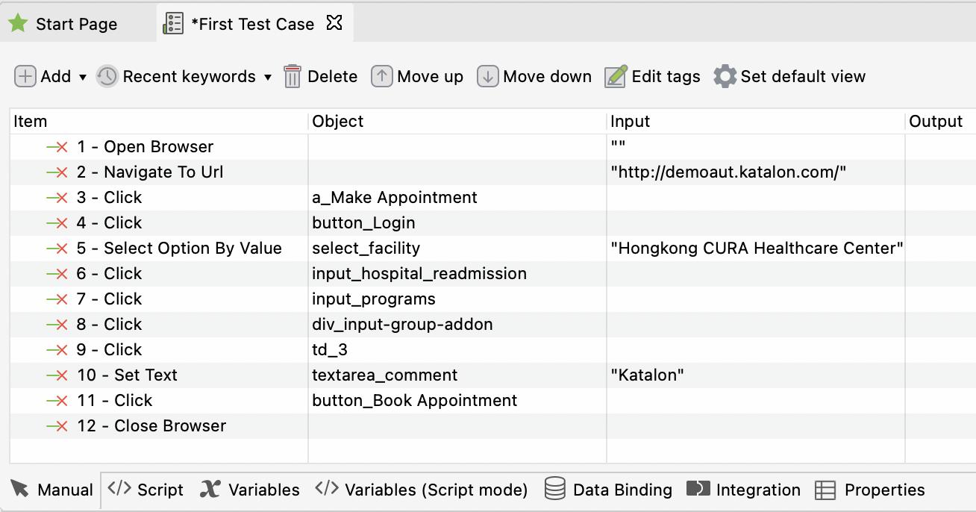
  - Add Test Steps – Manual View.

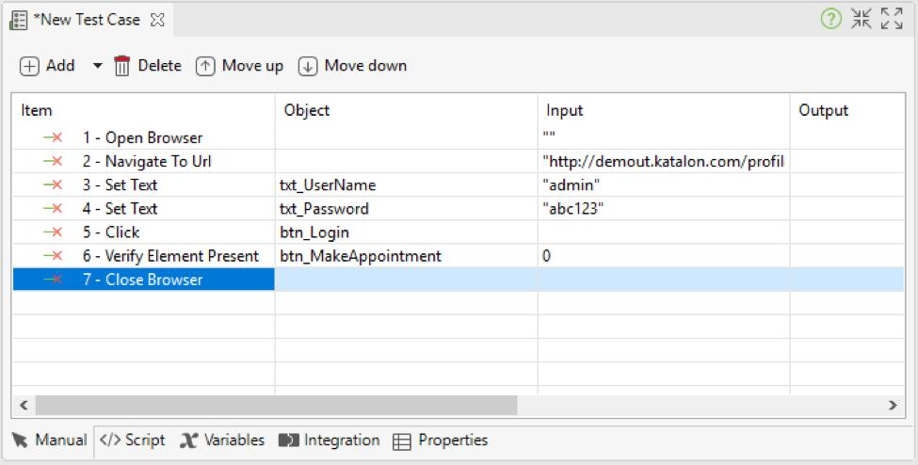

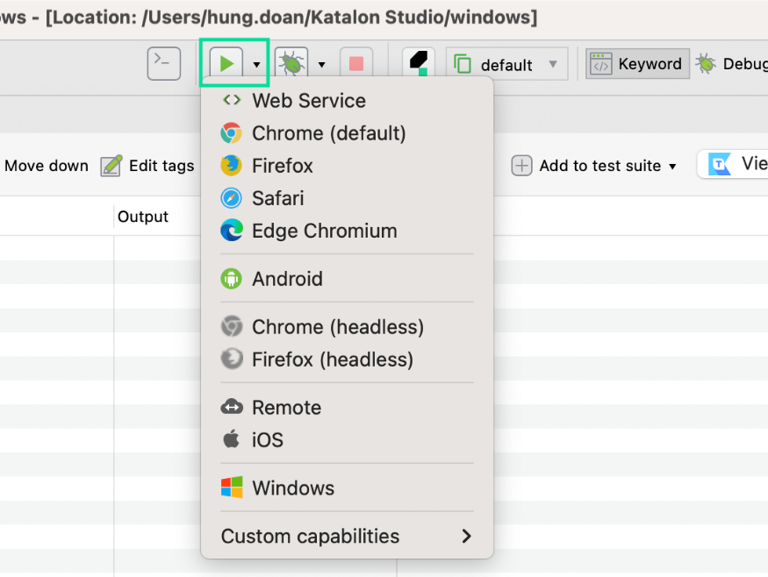
3.Run Test / Browser Selection

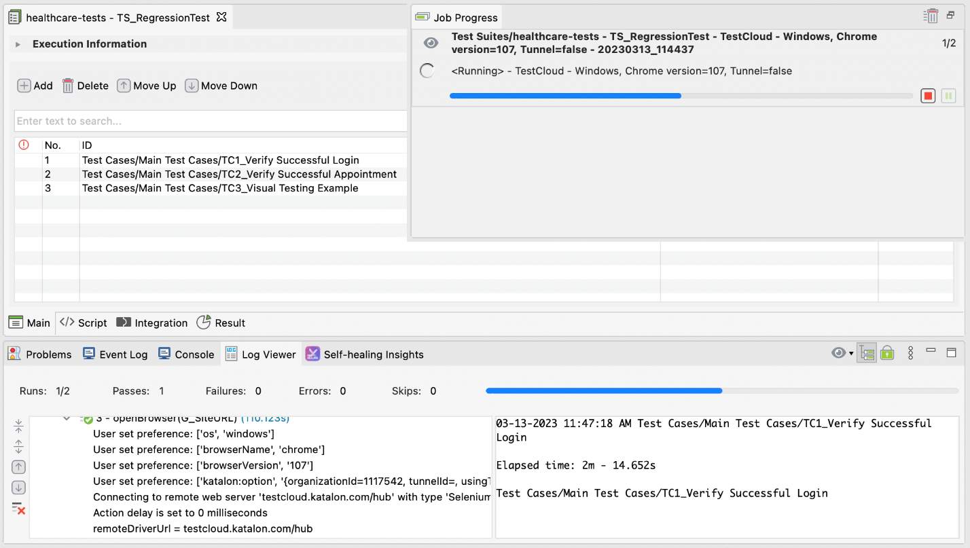

4. Create a comparison table with 4 columns (Tool Name, Type of Testing, Scripting Required, Example Use Case) for Selenium, Cypress, Katalon Studio, and Postman. Fill in the details based on your own research.
Ans:

Tool Name | Type of Testing | Scripting Required | Example Use Case
Selenium | Web UI / End-to-End Testing | Yes – Java, Python, C#, JavaScript, etc. | Automating login, signup, checkout, and form testing on websites
Cypress | Web End-to-End & Component Testing | Yes – mainly JavaScript/TypeScript | Testing a web application's login flow, buttons, forms, and page interactions
Katalon Studio | Web, API, Mobile & Desktop Testing | Optional – Manual/low-code mode available; scripting with Groovy/Java when needed | Creating automated web or API tests using its recorder and manual test steps
Postman | API Testing | Optional – JavaScript for advanced test scripts | Testing REST APIs, checking status codes, response data, authentication, etc.
5. Pick one real-world scenario from your daily app usage (such as searching for a product on Flipkart or booking a movie on BookMyShow). Write a short paragraph describing how you would automate this scenario using any automation tool covered in class.
Ans:
Real-World Automation Scenario: Searching for a Product on Flipkart
I would automate the product search process on Flipkart using Selenium. First, Selenium would open the Flipkart website in a browser. Then, it would locate the search box and automatically enter a product name such as “Laptop”. The script would click the search button and verify that the search results are displayed correctly. It could also check the product name, price, and availability. This automation would save time, reduce repetitive manual work, and allow the same test to be executed multiple times quickly.

